J14. RUTHERFORD PAINTINGS SERIES [A : n.l. 1909 / B : 1915]

At Geraldine Rutherford
F Printed in coloured half-tone from painting ; title and other printing in purple (A) ; a variation (B) has the back with the slogan 'Australia Day : Bathurst, July 30, 1915.' The City of Bathurst was founded in 1815, so this printing may well have been associated with some centenary observance.

These paintings also appeared in the artist's anonymous 'Views of the Jenolan Caves, N.S.W.' Vol. 2 (?1908). Our numbers below correspond with the plate numbers from that work.

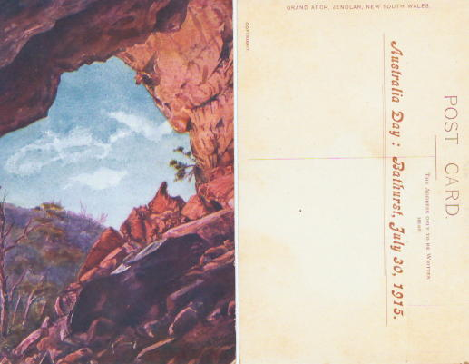
J14A.
J14A.1 Grand Arch, Jenolan, New South Wales V [pm.2 Apr.1912] (This painting was used as the frontispiece to Trickett's Guide to Jenolan, 2nd.edn.)
J14A.2 Shawl Cave, Jenolan, New South Wales V [pm.3 Feb. 1909]
J14A.3 Carlotta Arch, Jenolan, New South J6B.4 Alabaster Column, Jenolan, New South Wales V
J14A.5 Entrance to Lucas Cave, Jenolan, New South Wales V [ms. 16 May 1909]
J14A.6 Study of Colouring, Right Imperial, Jenolan, New South Wales H [ms.16 May 1909]

J14B.
J14B.1 Grand Arch, Jenolan, New South Wales V
J14B.3 Carlotta Arch, Jenolan, New South Wales V
J14B.6 Study of Colouring, Right Imperial, Jenolan, New South Wales H

